Amplifier

🔊 What Is an Amplifier?
# Source: AI Source: Provided by: [Data Path: Persons Table -> ID Column: 1, Name_En Column: Motasem Essam] -> From: [ChatGPT] on [1/23/2026]
An amplifier is an electronic device or circuit that increases the strength (amplitude) of a signal — whether it's audio, radio, or electrical power. In short:
✅ An amplifier takes a weak signal and makes it stronger.

📶 What Does an Amplifier Do?
# Source: AI Source: Provided by: [Data Path: Persons Table -> ID Column: 1, Name_En Column: Motasem Essam] -> From: [ChatGPT] on [1/23/2026]
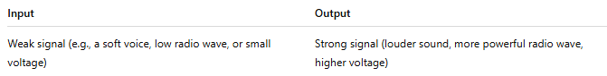

Input | Output
Weak signal (e.g., a soft voice, low radio wave, or small voltage) | Strong signal (louder sound, more powerful radio wave, higher voltage)
Amplifiers are used in everything from sound systems to radio transmitters and television broadcasting.

🔊 Why Use an Amplifier?
# Source: AI Source: Provided by: [Data Path: Persons Table -> ID Column: 1, Name_En Column: Motasem Essam] -> From: [ChatGPT] on [1/23/2026]
An amplifier is used to increase the power, voltage, or current of a signal so it can be heard, seen, processed, or transmitted effectively. Without amplification, many signals would be too weak to be useful.

🔧 Types of Amplifiers (By Function):
# Source: AI Source: Provided by: [Data Path: Persons Table -> ID Column: 1, Name_En Column: Motasem Essam] -> From: [ChatGPT] on [1/23/2026]
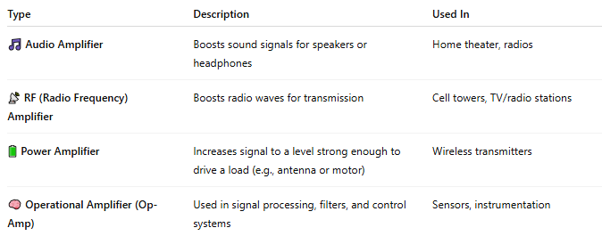

Type | Description | Used In
🎵 Audio Amplifier | Boosts sound signals for speakers or headphones | Home theater, radios
📡 RF (Radio Frequency) Amplifier | Boosts radio waves for transmission | Cell towers, TV/radio stations
🔋 Power Amplifier | Increases signal to a level strong enough to drive a load (e.g., antenna or motor) | Wireless transmitters
🧠 Operational Amplifier (Op-Amp) | Used in signal processing, filters, and control systems | Sensors, instrumentation

📡 Example in Wireless Communication:
# Source: AI Source: Provided by: [Data Path: Persons Table -> ID Column: 1, Name_En Column: Motasem Essam] -> From: [ChatGPT] on [1/23/2026]
- Oscillator generates a weak carrier wave.
- Modulator adds data to the carrier wave.
- ✅ Amplifier increases the strength of the modulated signal.
- 📡 Antenna transmits the strong signal over long distances.

🧠 Real-Life Examples:
# Source: AI Source: Provided by: [Data Path: Persons Table -> ID Column: 1, Name_En Column: Motasem Essam] -> From: [ChatGPT] on [1/23/2026]
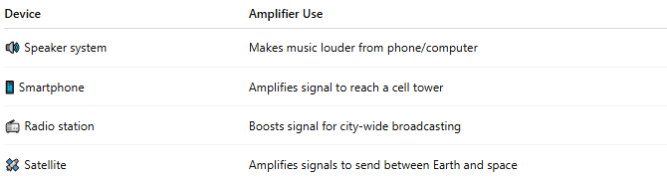

Device | Amplifier Use
🔊 Speaker system | Makes music louder from phone/computer
📱 Smartphone | Amplifies signal to reach a cell tower
📻 Radio station | Boosts signal for city-wide broadcasting
🛰️ Satellite | Amplifies signals to send between Earth and space

📖 Summary:
# Source: AI Source: Provided by: [Data Path: Persons Table -> ID Column: 1, Name_En Column: Motasem Essam] -> From: [ChatGPT] on [1/23/2026]
An amplifier is a critical component that boosts weak signals to make them usable, whether for sound, communication, or data. Without amplifiers, most signals would be too weak to hear, see, or transmit effectively.

